**Lesson 2: The Limit Concept**

After completing this lesson, you should be able to

* discuss the limit concept of functions
* explain the one-sided limit concept
* explain the infinite limit concept
* explain the limit concept at infinity and the end behavior of a function

**Commentary**

**Topics**

1. [Introduction to the Limit Concept of Functions](https://content.umuc.edu/file/7bdece95-b196-4233-9313-aa904663b08e/1/MATH140-0909.zip/Modules/M2-Module_2/Lesson_2/S3-Commentary.html#I)
2. [One-Sided Limit Concept](https://content.umuc.edu/file/7bdece95-b196-4233-9313-aa904663b08e/1/MATH140-0909.zip/Modules/M2-Module_2/Lesson_2/S3-Commentary.html#II)
3. [Infinite Limit Concept](https://content.umuc.edu/file/7bdece95-b196-4233-9313-aa904663b08e/1/MATH140-0909.zip/Modules/M2-Module_2/Lesson_2/S3-Commentary.html#III)
4. [Limit Concept at Infinity and End Behavior of a Function](https://content.umuc.edu/file/7bdece95-b196-4233-9313-aa904663b08e/1/MATH140-0909.zip/Modules/M2-Module_2/Lesson_2/S3-Commentary.html#IV)

**1. Introduction to the Limit Concept of Functions**

In the last lesson, we examined how limits arise as you find the tangent to a curve or the velocity of an object. In this lesson, we will further explore limits and how to compute them numerically and graphically.

**Exercise 2.2.1: Investigate the Behavior of a Function**

**Problem**

Investigate the behavior of the function https://content.umuc.edu/file/7bdece95-b196-4233-9313-aa904663b08e/1/MATH140-0909.zip/Modules/M2-Module_2/Lesson_2/images/MATH14-mod2-lessn2-excr2-2-1.gif near *x* = 2.

**https://content.umuc.edu/file/7bdece95-b196-4233-9313-aa904663b08e/1/MATH140-0909.zip/Modules/M2-Module_2/Lesson_2/images/Figurer2-2-1-figurehead.gif**

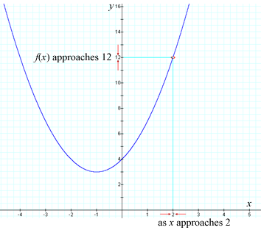

**Solution**

To get a sense of the behavior of the graph of *f*(*x*) at *x* = 2, we use values of *x* that are close to, but not equal to, 2.

**Table 2.2.1  
Values of *x* Close to 2**

|  |  |  |  |
| --- | --- | --- | --- |
| ***x*** | ***f*(*x*)** | ***x*** | ***f*(*x*)** |
| 1.9 | 11.41 | 2.1 | 12.61 |
| 1.99 | 11.94 | 2.01 | 12.06 |
| 1.999 | 11.994 | 2.001 | 12.006 |
| 1.9999 | 11.999 | 2.0001 | 12.001 |

We observe from table 2.2.1 and figure 2.2.1 that, as the values of *x* get closer and closer to 2 from both the left side and the right side of 2, the value of *f*(*x*) becomes closer to 12.

We can write this mathematically as

https://content.umuc.edu/file/7bdece95-b196-4233-9313-aa904663b08e/1/MATH140-0909.zip/Modules/M2-Module_2/Lesson_2/images/Table2-2-1-eq.gif

We will use the following informal approach to limits until we discuss them more thoroughly in lesson 4.

Concept of a Limit

If *f*(*x*) becomes arbitrarily close to a number *L* (or as close as we wish) through our consideration of values of *x* sufficiently close to *C* from either side, though not equal to *c*, the **limit of *f*(*x*) as *x* approaches *c* is *L***.

Mathematically, we write this as

https://content.umuc.edu/file/7bdece95-b196-4233-9313-aa904663b08e/1/MATH140-0909.zip/Modules/M2-Module_2/Lesson_2/images/limit-x-to-c.gif *f*(*x*) = *L*

which is read as, "the limit of *f*(*x*) as*x* approaches *c* is equal to *L*."

As we saw in our investigation of the behavior of https://content.umuc.edu/file/7bdece95-b196-4233-9313-aa904663b08e/1/MATH140-0909.zip/Modules/M2-Module_2/Lesson_2/images/MATH14-mod2-lessn2-excr2-2-1.gif  near *x* = 2, the limit of the function *f*(*x*) as *x* approaches *a* does not necessarily depend on how the function is actually defined at *x* = *c*.

**Exercise 2.2.2: Approximate the Value of Limits**

**Problem**

Approximate the value of each of the following limits:

1. https://content.umuc.edu/file/7bdece95-b196-4233-9313-aa904663b08e/1/MATH140-0909.zip/Modules/M2-Module_2/Lesson_2/images/MATH14-mod2-lessn2-ex2-2-2a.gif
2. https://content.umuc.edu/file/7bdece95-b196-4233-9313-aa904663b08e/1/MATH140-0909.zip/Modules/M2-Module_2/Lesson_2/images/MATH14-mod2-lessn2-ex2-2-2b.gif
3. https://content.umuc.edu/file/7bdece95-b196-4233-9313-aa904663b08e/1/MATH140-0909.zip/Modules/M2-Module_2/Lesson_2/images/MATH14-mod2-lessn2-ex2-2-2c.gif

**Solution**

1. We observe that, although the function *f*(*x*) = (*x*2 – 4)/ (*x* – 2) is not defined at *x* = 2, we can still use the definition of the limit of *f*(*x*) as *x* approaches *a.* This enables us to consider values of *x* that are close to, but not equal to, *a*. Table 2.2.2 shows us that, as values of *x* get closer to 2 (from both sides), though not close enough to equal 2, the values of *f*(*x*) = (*x*2 – 4)/(*x* – 2) also seem to get closer to 2.

**Table 2.2.2  
Values of *x* and *f*(*x*)**

|  |  |  |  |
| --- | --- | --- | --- |
| ***x*** | ***f*(*x*)** | ***x*** | ***f*(*x*)** |
| 1.9 | 3.9 | 2.1 | 4.1 |
| 1.99 | 3.99 | 2.01 | 4.01 |
| 1.999 | 3.999 | 2.001 | 4.001 |
| 1.9999 | 3.9999 | 2.0001 | 4.0001 |

This can be written mathematically:

https://content.umuc.edu/file/7bdece95-b196-4233-9313-aa904663b08e/1/MATH140-0909.zip/Modules/M2-Module_2/Lesson_2/images/MATH14-mod2-lessn2-ex2-2-2aa.gif

Graphically, we can see that the limit of *f*(*x*) is 4 as *x* nears 2 (see figure 2.2.2a).

**https://content.umuc.edu/file/7bdece95-b196-4233-9313-aa904663b08e/1/MATH140-0909.zip/Modules/M2-Module_2/Lesson_2/images/MATH14-mod2-lessn2-ex2-2-2-figtitle.gif**

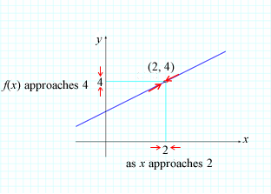

1. Similarly, we can observe that the limit of *g*(*x*) appears to be 4 as *x* nears 2 from either side, even though *g*(2) = 2 is not the same value as the limit (see figure 2.2.2b).

**https://content.umuc.edu/file/7bdece95-b196-4233-9313-aa904663b08e/1/MATH140-0909.zip/Modules/M2-Module_2/Lesson_2/images/MATH14-mod2-lessn2-ex2-2-2b-soltn.gif**

**https://content.umuc.edu/file/7bdece95-b196-4233-9313-aa904663b08e/1/MATH140-0909.zip/Modules/M2-Module_2/Lesson_2/images/MATH14-mod2-lessn2-ex2-2-2b-figtitle.gif**

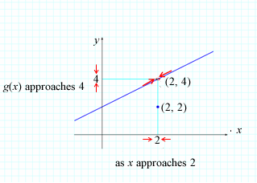

1. The limit of *h* as *x* nears 2 also appears to be 4 (see figure 2.2.2c).

**https://content.umuc.edu/file/7bdece95-b196-4233-9313-aa904663b08e/1/MATH140-0909.zip/Modules/M2-Module_2/Lesson_2/images/MATH14-mod2-lessn2-ex2-2-2c-figtitle.gif**

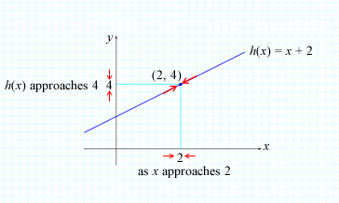

**Note This**

|  |  |
| --- | --- |
| https://content.umuc.edu/file/7bdece95-b196-4233-9313-aa904663b08e/1/MATH140-0909.zip/Modules/M2-Module_2/Lesson_2/images/NoteThisIcon.png | Each of the limits of *f*(*x*), *g*(*x*), and *h*(*x*) equals 4 as *x* nears 2; however, the function values of each function differ: *f*(2) does not exist; *g*(2) = 2; and *h*(2) = 4. Note that *h* is the only function in this example whose function value is the same as the limit value—that is, https://content.umuc.edu/file/7bdece95-b196-4233-9313-aa904663b08e/1/MATH140-0909.zip/Modules/M2-Module_2/Lesson_2/images/limit-x-to-2.gif*h*(*x*) = *h*(2) = 4. |

The special property of a function, of having the same limit value and function value, is called *continuity* and will be discussed further in lesson 5.

**Exercise 2.2.3: Approximate a Value I**

**Problem**

Approximate the value of https://content.umuc.edu/file/7bdece95-b196-4233-9313-aa904663b08e/1/MATH140-0909.zip/Modules/M2-Module_2/Lesson_2/images/MATH14-mod2-lessn2-ex2-2-3-prob.gif.

**Solution**

The values for *x* are in radians, so be sure to put your calculator in radian mode.

**Table 2.2.3  
Values of *x* and *f*(*x*)**

|  |  |  |  |
| --- | --- | --- | --- |
| ***x*** | ***f*(*x*)** | ***x*** | ***f*(*x*)** |
| 0.1 | 0.99833333 | –0.1 | 0.99833333 |
| 0.01 | 0.99998333 | –0.01 | 0.99998333 |
| 0.001 | 0.99999983 | –0.001 | 0.99999983 |
| 0.0001 | 0.99999998 | –0.0001 | 0.99999998 |

**https://content.umuc.edu/file/7bdece95-b196-4233-9313-aa904663b08e/1/MATH140-0909.zip/Modules/M2-Module_2/Lesson_2/images/MATH14-mod2-lessn2-ex2-2-3-figtitle.gif**

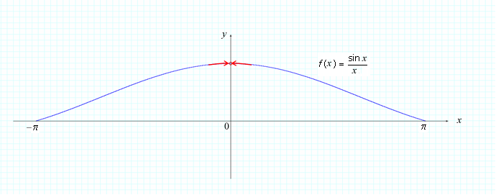

Both the table and the graph suggest that https://content.umuc.edu/file/7bdece95-b196-4233-9313-aa904663b08e/1/MATH140-0909.zip/Modules/M2-Module_2/Lesson_2/images/MATH14-mod2-lessn2-ex2-2-3-prob.gif = 1, and this will be proven in module 3. Some functions do not have a limit, as we will see in the following exercise.

**Exercise 2.2.4: Explore a Value**

**Problem**

Explore https://content.umuc.edu/file/7bdece95-b196-4233-9313-aa904663b08e/1/MATH140-0909.zip/Modules/M2-Module_2/Lesson_2/images/MATH14-mod2-lessn2-ex2-2-4.gif.

**Solution**

Let https://content.umuc.edu/file/7bdece95-b196-4233-9313-aa904663b08e/1/MATH140-0909.zip/Modules/M2-Module_2/Lesson_2/images/MATH14-mod2-lessn2-ex2-2-4a-soltn.gif, and note that the function is not defined for *x* = 0. We will explore the limit of *f*(*x*) as *x* nears 0 by considering smaller and smaller values of *x*(see table 2.2.4).

**Table 2.2.4  
Values of *x* and *f*(*x*)**

|  |  |
| --- | --- |
| ***x*** | ***f*(*x*)** |
| ±0.1 |  |
| ±0.01 |  |
| ±0.001 |  |
| ±0.0001 |  |

This would suggest that a reasonable approximation forhttps://content.umuc.edu/file/7bdece95-b196-4233-9313-aa904663b08e/1/MATH140-0909.zip/Modules/M2-Module_2/Lesson_2/images/MATH14-mod2-lessn2-ex2-2-4aa-soltn.gif is 0; however, this is not correct. Why do we think that this approximation is correct, and how can we determine that, in fact, the limit does not exist? The function oscillates a lot near 0! This extreme oscillation suggests that the limit may not exist, as the values of this function do not approach a particular number as *x* approaches 0.

Consider the following table of values that also approach 0:

**Table 2.2.5  
Values of *x* and *f*(*x*)**

|  |  |
| --- | --- |
| ***x*** | ***f*(*x*)** |
| ±2/π | 1 |
| ±2/3π | –1 |
| ±2/5π | 1 |
| ±2/7π | –1 |

For any open interval containing 0, this function oscillates between –1 and 1. Because the values of this function do not approach a particular value (the function simply oscillates too much as it nears 0),

https://content.umuc.edu/file/7bdece95-b196-4233-9313-aa904663b08e/1/MATH140-0909.zip/Modules/M2-Module_2/Lesson_2/images/lim-x-to-0-sin-x.gif does not exist.

As the values of *x* approach 0 from either side, the values in the table do not approach a particular limit value; they oscillate between 1 and –1. You can see this in figure 2.2.4:

**Figure 2.2.4**

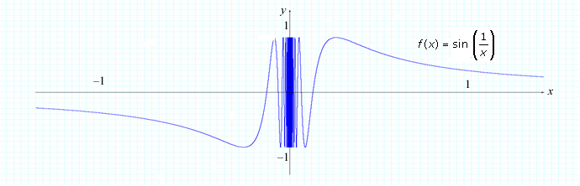

**Exercise 2.2.5: Approximate a Value II**

**Problem**

Approximate the value of https://content.umuc.edu/file/7bdece95-b196-4233-9313-aa904663b08e/1/MATH140-0909.zip/Modules/M2-Module_2/Lesson_2/images/MATH14-mod2-lessn2-ex2-2-5-prob.gif.

**Solution**

Consider the table of values for *x* near 0 (from either side of 0):

**Table 2.2.6  
Values for *x* Near 0**

|  |  |  |  |
| --- | --- | --- | --- |
| ***x*** | ***f*(*x*)** | ***x*** | ***f*(*x*)** |
| 0.1 | 0.24984 | –0.1 | 0.24984 |
| 0.01 | 0.24999 | –0.01 | 0.24999 |
| 0.001 | 0.25 | –0.001 | 0.25 |
| 0.0001 | 0.25 | –0.0001 | 0.25 |

The limit values appear to approach 0.25, suggesting that

**https://content.umuc.edu/file/7bdece95-b196-4233-9313-aa904663b08e/1/MATH140-0909.zip/Modules/M2-Module_2/Lesson_2/images/MATH14-mod2-lessn2-ex2-2-5-prob1.gif**

However, when we consider even smaller values of *x* (values that are even closer to 0), something unexpected occurs:

**Table 2.2.7  
Smaller Values of *x***

|  |  |
| --- | --- |
| ***x*** | ***f*(*x*)** |
| ±0.00001 | 0.25 |
| ±0.000001 | 0.000000 |
| ±0.0000001 | 0.0000000 |
| ±0.00000001 | 0.00000000 |

Why is there an inconsistency, and which answer is correct, 0 or 1/4? The answer 1/4 is correct, as we will confirm beyond a doubt in lesson 4, when we precisely define limits.

The inconsistency arises as *x* becomes very close to 0. The quantity gets very close to 2, and eventually, the calculator's value is incorrectly rounded to 2.0000. . . to as many digits as it is programmed to manage. We can visualize this behavior by considering smaller and smaller viewing windows (closer and closer to *x* = 0).

In figures 2.2.5a and 2.2.5b below, the limit appears correctly as 1/4; however, as we move closer to 0 by considering smaller and smaller *x* values for the viewing window, something peculiar occurs (see figures 2.2.5c and 2.2.5d).

* 1. <–1, 1, 0.1> by <–0.1, 0.6, 0.1>

**Figure 2.2.5a  
<–1, 1, 0.1> by <–0.1, 0.6, 0.1>**

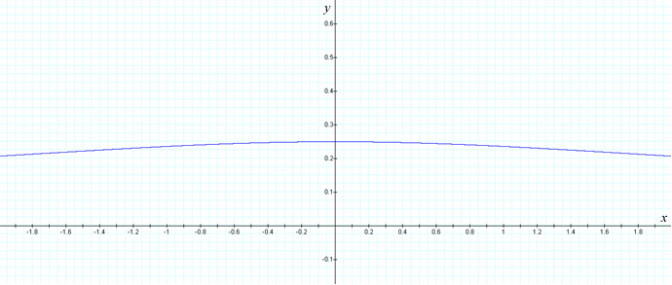

* 1. <–0.1, 0.1, 0.02> by <–0.1, 0.6, 0.1>

**Figure 2.2.5b  
<–0.1, 0.1, 0.02> by <–0.1, 0.6, 0.1>**

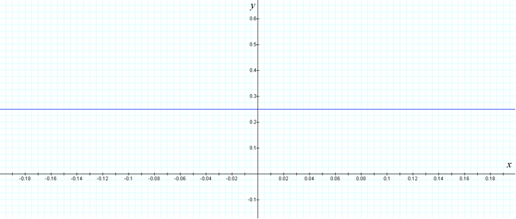

* 1. <–10–6, 10–6, 2*x*10–7> by <–0.1, 0.6, 0.1>

**Figure 2.2.5c  
<–10–6, 10–6, 2*x*10–7> by <–0.1, 0.6, 0.1>**

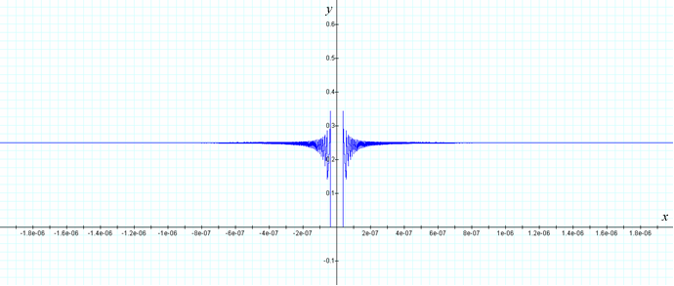

* 1. <–10–7, 10–7, 2*x*10–8> by <–0.1, 0.6, 0.1>

**Figure 2.2.5d  
<–10–7, 10–7, 2*x*10–8> by <–0.1, 0.6, 0.1>**

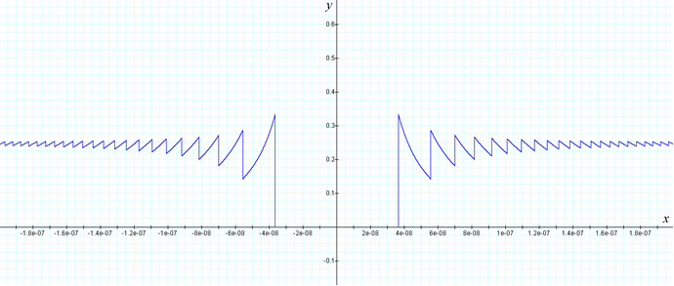

The precise definition of a limit provided in lesson 4 will help us to clarify situations such as this, where the informal definition of a limit does not suffice.

**Example 2.2.1: The Signum Function**

The **signum function** (from the Latin "sign") is the function that extracts the sign of a real number.

This function, often represented as **sgn**, is defined in the following manner:

**sgn**(*x*) https://content.umuc.edu/file/7bdece95-b196-4233-9313-aa904663b08e/1/MATH140-0909.zip/Modules/M2-Module_2/Lesson_2/images/signum-functn.gif

**Problem**

Discuss https://content.umuc.edu/file/7bdece95-b196-4233-9313-aa904663b08e/1/MATH140-0909.zip/Modules/M2-Module_2/Lesson_2/images/limit-x-to-0.gif**sgn**(*x*).

**Solution**

See figure 2.2.6:

**Figure 2.2.6**

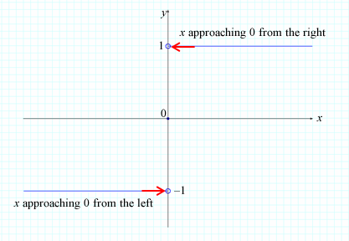

As *x* approaches 0 from the right, the value of **sgn**(*x*) approaches 1. As *x* approaches 0 from the left, the value of **sgn**(*x*) approaches –1. The limiting values of**sgn**(*x*) do not tend toward a single value, and therefore, https://content.umuc.edu/file/7bdece95-b196-4233-9313-aa904663b08e/1/MATH140-0909.zip/Modules/M2-Module_2/Lesson_2/images/limit-x-to-0.gif**sgn**(*x*) does not exist.

Now, we will consider one-sided limits, or the limits that occur as *x* approaches a number from either the left or the right side.

**2. One-Sided Limit Concept**

As we saw in the example above, **sgn**(*x*) approaches 1 as *x* approaches 0 from the right, and **sgn**(*x*) approaches –1 as *x* approaches 0 from the left. We can write these limits using the following notations:

https://content.umuc.edu/file/7bdece95-b196-4233-9313-aa904663b08e/1/MATH140-0909.zip/Modules/M2-Module_2/Lesson_2/images/limit-x-to-0-plus.gif **sgn**(*x*) = 1 AND https://content.umuc.edu/file/7bdece95-b196-4233-9313-aa904663b08e/1/MATH140-0909.zip/Modules/M2-Module_2/Lesson_2/images/limit-x-to-0-neg.gif **sgn** (*x*) = –1

When we write **https://content.umuc.edu/file/7bdece95-b196-4233-9313-aa904663b08e/1/MATH140-0909.zip/Modules/M2-Module_2/Lesson_2/images/limit-x-to-0-plus.gif**, we are considering only those values of *x* that are greater than 0; the notation **https://content.umuc.edu/file/7bdece95-b196-4233-9313-aa904663b08e/1/MATH140-0909.zip/Modules/M2-Module_2/Lesson_2/images/limit-x-to-0-neg.gif** suggests that we are considering only those values of *x* that are lower than 0.

Definition 1: Right-Side Limit

We say that *f*(*x*) has a **right-side limit** *LR* at *c*, and write

https://content.umuc.edu/file/7bdece95-b196-4233-9313-aa904663b08e/1/MATH140-0909.zip/Modules/M2-Module_2/Lesson_2/images/limit-x-to-c-plus.gif *f*(*x*) = *LR* (see figure 2.2.7a)

if we can make *f*(*x*) arbitrarily close to *LR* by considering values of *x* sufficiently close to*c*(*x* ≠ *c*), where *x* > *c* (with *x* approaching *c* from the right).

Definition 2: Left-Side Limit

We say that *f*(*x*) has a **left-side limit** *LL* at *c*, and write

https://content.umuc.edu/file/7bdece95-b196-4233-9313-aa904663b08e/1/MATH140-0909.zip/Modules/M2-Module_2/Lesson_2/images/limit-x-to-c-minus.gif *f*(*x*) = *LL* (see figure 2.2.7b)

if we can make *f*(*x*) arbitrarily close to*LL* by considering values of *x* sufficiently close to*c*(*x* ≠ *c*), where *x* < *c*(with *x* approaching*c*from the left).

As *x* approaches *c* from the right, *f*(*x*) approaches *LR*:

**Figure 2.2.7a  
Right-Side Limit**

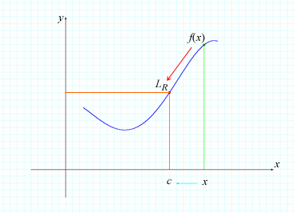

As *x* approaches *c*from the left, *f*(*x*) approaches *LL*:

**Figure 2.2.7b  
Left-Side Limit**

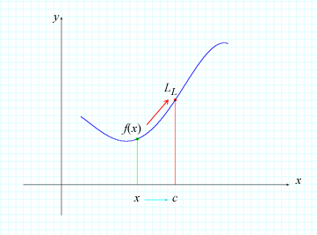

Using the definition of one-sided limits and our working definition of limits, we can form the following theorem:

https://content.umuc.edu/file/7bdece95-b196-4233-9313-aa904663b08e/1/MATH140-0909.zip/Modules/M2-Module_2/Lesson_2/images/limit-x-to-c.gif*f*(*x*) = *L* IF AND ONLY IF https://content.umuc.edu/file/7bdece95-b196-4233-9313-aa904663b08e/1/MATH140-0909.zip/Modules/M2-Module_2/Lesson_2/images/limit-x-to-c-plus.gif*f*(*x*) = *L* AND https://content.umuc.edu/file/7bdece95-b196-4233-9313-aa904663b08e/1/MATH140-0909.zip/Modules/M2-Module_2/Lesson_2/images/limit-x-to-c-minus.gif*f*(*x*) = *L*

In other words, a function *f*(*x*) has a limit *L* as *x* approaches *c* if and only if the right-side limit and the left–side limit both exist and both are equal to *L*.

**Exercise 2.2.6: Determine Whether or Not a Limit Exists I**

**Problem**

Given the graph of the function *F*(*x*) (see figure 2.2.8), determine whether or not https://content.umuc.edu/file/7bdece95-b196-4233-9313-aa904663b08e/1/MATH140-0909.zip/Modules/M2-Module_2/Lesson_2/images/limit-x-to-c.gif*F*(*x*) exists.

**Figure 2.2.8  
Graph of *F*(*x*)**

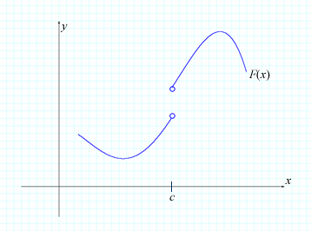

**Solution**

As we can see in figure 2.2.9,https://content.umuc.edu/file/7bdece95-b196-4233-9313-aa904663b08e/1/MATH140-0909.zip/Modules/M2-Module_2/Lesson_2/images/limit-x-to-c-plus.gif *F*(*x*) = *LR* ≠ *LL* = https://content.umuc.edu/file/7bdece95-b196-4233-9313-aa904663b08e/1/MATH140-0909.zip/Modules/M2-Module_2/Lesson_2/images/limit-x-to-c-minus.gif *F*(*x*) (in other words, the graph "jumps" at *x* = *c*). Thus, *F*(*x*) does not exist.

**Figure 2.2.9  
Graph "Jumping" at *x* = *c***

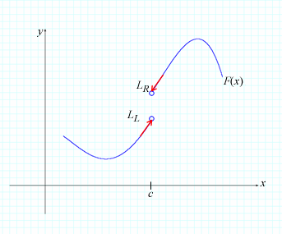

**3. Infinite Limit Concept**

In some cases, we find that the limit becomes arbitrarily large (positive or negative) as we consider values approaching a particular number from either side of that number. Consider the following exercise.

**Exercise 2.2.7: Determine Whether or Not a Limit Exists II**

**Problem**

Determine whether or not https://content.umuc.edu/file/7bdece95-b196-4233-9313-aa904663b08e/1/MATH140-0909.zip/Modules/M2-Module_2/Lesson_2/images/MATH14-mod2-lessn2-ex2-2-6prob.gif exists.

**Solution**

We see in figure 2.2.10 below that, as *x* nears 0 from the left and the right, the value of 1/*x*2 becomes arbitrarily large. Therefore, the limit does *not* approach a finite number *L*, and we say that 1/*x*2 has no limit as *x* approaches 0.

**Table 2.2.8  
Values for *x* as *f*(*x*) = 1/*x*2**

|  |  |
| --- | --- |
| ***x*** | ***f*(*x*) = 1/*x*2** |
| ±0.1 | 100 |
| ±0.01 | 10,000 |
| ±0.001 | 1,000,000 |
| ±0.0001 | 100,000,000 |
| ±0.00001 | 10,000,000,000 |

**Figure 2.2.10  
Values of 1/*x*2**

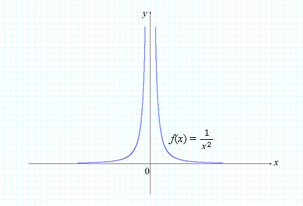

We can write this limiting behavior of 1/*x*2 mathematically using the following notation:

https://content.umuc.edu/file/7bdece95-b196-4233-9313-aa904663b08e/1/MATH140-0909.zip/Modules/M2-Module_2/Lesson_2/images/MATH14-mod2-lessn2-ex2-2-6prob.gif = ∞

Definition 3

If *f*(*x*) is a function defined on both sides of *c*, except perhaps at *c* itself, then

https://content.umuc.edu/file/7bdece95-b196-4233-9313-aa904663b08e/1/MATH140-0909.zip/Modules/M2-Module_2/Lesson_2/images/limit-x-to-c.gif *f*(*x*) = ∞

means that the limit of *f*(*x*) becomes arbitrarily large (in a positive fashion) as *x* approaches *c* from both sides without equaling *c*.

**Note This**

|  |  |
| --- | --- |
| https://content.umuc.edu/file/7bdece95-b196-4233-9313-aa904663b08e/1/MATH140-0909.zip/Modules/M2-Module_2/Lesson_2/images/NoteThisIcon.png | We are not suggesting that ∞ is a number (it is not). The above is simply a notation to describe the behavior of the graph of *f*(*x*) as *x*nears *c*. |

**Exercise 2.2.8: Find a Limit if it Exists**

**Problem**

Find https://content.umuc.edu/file/7bdece95-b196-4233-9313-aa904663b08e/1/MATH140-0909.zip/Modules/M2-Module_2/Lesson_2/images/MATH14-mod2-lessn2-ex2-2-7prob.gif, if it exists.

**Solution**

We can see in table 2.2.9 and figure 2.2.11 below that, as *x* nears 0 from the left and the right, the value of –1/*x*4 becomes arbitrarily large in a negative fashion. The limit does not approach a *finite*number *L*, so we say that –1/*x*4 has no limit as *x* approaches 0.

**Table 2.2.9  
Values for *x* as *f*(*x*) = 1/*x*4**

|  |  |
| --- | --- |
| ***x*** | ***f*(*x*) = 1/*x*4** |
| ±0.1 | –10,000 |
| ±0.01 | –100,000,000 |
| ±0.001 | –1,000,000,000,000 |
| ±0.0001 | –1016 |
| ±0.00001 | –1020 |

**Figure 2.2.11  
Values of 1/*x*4**

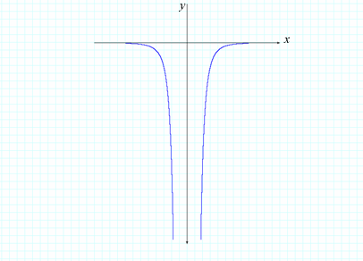

We write this limit behavior of –1/*x*4 symbolically as

https://content.umuc.edu/file/7bdece95-b196-4233-9313-aa904663b08e/1/MATH140-0909.zip/Modules/M2-Module_2/Lesson_2/images/MATH14-mod2-lessn2-ex2-2-7prob.gif = –∞

**Stop and Think:** The limit https://content.umuc.edu/file/7bdece95-b196-4233-9313-aa904663b08e/1/MATH140-0909.zip/Modules/M2-Module_2/Lesson_2/images/limit-x-to-0.gif https://content.umuc.edu/file/7bdece95-b196-4233-9313-aa904663b08e/1/MATH140-0909.zip/Modules/M2-Module_2/Lesson_2/images/one-over-x-cubed.gif  is neither –∞ nor ∞, as https://content.umuc.edu/file/7bdece95-b196-4233-9313-aa904663b08e/1/MATH140-0909.zip/Modules/M2-Module_2/Lesson_2/images/limit-x-to-0-minus-.gif https://content.umuc.edu/file/7bdece95-b196-4233-9313-aa904663b08e/1/MATH140-0909.zip/Modules/M2-Module_2/Lesson_2/images/one-over-x-cubed.gif ≠  https://content.umuc.edu/file/7bdece95-b196-4233-9313-aa904663b08e/1/MATH140-0909.zip/Modules/M2-Module_2/Lesson_2/images/one-over-x-cubed.gif. In this case, we say that https://content.umuc.edu/file/7bdece95-b196-4233-9313-aa904663b08e/1/MATH140-0909.zip/Modules/M2-Module_2/Lesson_2/images/limit-x-to-0.gifhttps://content.umuc.edu/file/7bdece95-b196-4233-9313-aa904663b08e/1/MATH140-0909.zip/Modules/M2-Module_2/Lesson_2/images/one-over-x-cubed.gif does not exist, which is different from saying that it has no limit.

Why is there a difference between the statements "*https://content.umuc.edu/file/7bdece95-b196-4233-9313-aa904663b08e/1/MATH140-0909.zip/Modules/M2-Module_2/Lesson_2/images/limit-x-to-c.giff*(*x*) has no limit" and "*https://content.umuc.edu/file/7bdece95-b196-4233-9313-aa904663b08e/1/MATH140-0909.zip/Modules/M2-Module_2/Lesson_2/images/limit-x-to-c.giff*(*x*) does not exist"?

We have the following definition when a function *f*(*x*) becomes arbitrarily large (in a negative fashion):

Definition 4

If *f*(*x*) is a function defined on both sides of *c*, except perhaps at *c* itself, then

*https://content.umuc.edu/file/7bdece95-b196-4233-9313-aa904663b08e/1/MATH140-0909.zip/Modules/M2-Module_2/Lesson_2/images/limit-x-to-c.giff*(*x*) = –∞

means that the limit of *f*(*x*) becomes arbitrarily large (in a negative fashion) as *x* approaches *c*from both sides without equaling *c*.

Also,

Definition 5

If *f*(*x*) is a function defined on both sides of *c*, except perhaps at *c*itself, then

* 1. https://content.umuc.edu/file/7bdece95-b196-4233-9313-aa904663b08e/1/MATH140-0909.zip/Modules/M2-Module_2/Lesson_2/images/limit-x-to-c-plus.gif *f*(*x*) = ∞ if the limit of *f*(*x*) becomes arbitrarily large (in a positive fashion) as *x* approaches *c* from the right (see figure 2.2.12a).
  2. https://content.umuc.edu/file/7bdece95-b196-4233-9313-aa904663b08e/1/MATH140-0909.zip/Modules/M2-Module_2/Lesson_2/images/limit-x-to-c-plus.gif *f*(*x*) = –∞ if the limit of *f*(*x*) becomes arbitrarily large (in a negative fashion) as *x* approaches*c*from the right (see 2.2.12b).
  3. https://content.umuc.edu/file/7bdece95-b196-4233-9313-aa904663b08e/1/MATH140-0909.zip/Modules/M2-Module_2/Lesson_2/images/limit-x-to-c-minus.gif *f*(*x*) = ∞ if the limit of *f*(*x*) becomes arbitrarily large (in a positive fashion) as *x* approaches*c*from the left (see 2.2.12c).
  4. https://content.umuc.edu/file/7bdece95-b196-4233-9313-aa904663b08e/1/MATH140-0909.zip/Modules/M2-Module_2/Lesson_2/images/limit-x-to-c-minus.gif *f*(*x*) = –∞ if the limit of *f*(*x*) becomes arbitrarily large (in a negative fashion) as *x* approaches*c*from the left (see 2.2.12d).

We have a similar definition for one-sided limits.

**Figure 2.2.12a  
https://content.umuc.edu/file/7bdece95-b196-4233-9313-aa904663b08e/1/MATH140-0909.zip/Modules/M2-Module_2/Lesson_2/images/limit-x-to-c-plus.gif *f*(*x*) = ∞**

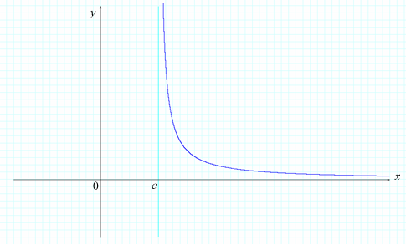

**Figure 2.2.12b  
https://content.umuc.edu/file/7bdece95-b196-4233-9313-aa904663b08e/1/MATH140-0909.zip/Modules/M2-Module_2/Lesson_2/images/limit-x-to-c-plus.gif *f*(*x*) = –∞**

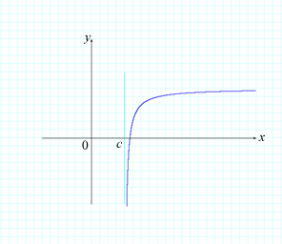

**Figure 2.2.12c  
https://content.umuc.edu/file/7bdece95-b196-4233-9313-aa904663b08e/1/MATH140-0909.zip/Modules/M2-Module_2/Lesson_2/images/limit-x-to-c-minus.gif *f*(*x*) = ∞**

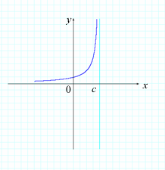

**Figure 2.2.12d  
https://content.umuc.edu/file/7bdece95-b196-4233-9313-aa904663b08e/1/MATH140-0909.zip/Modules/M2-Module_2/Lesson_2/images/limit-x-to-c-minus.gif *f*(*x*) = –∞**

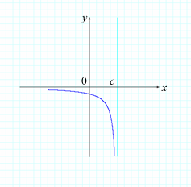

We use the results on infinite limits to define the following geometric characteristics.

**Definition 6**

A line *x* = *c* is called a **vertical asymptote** of the graph of a function *y* = *f*(*x*) if any of the following conditions hold:

https://content.umuc.edu/file/7bdece95-b196-4233-9313-aa904663b08e/1/MATH140-0909.zip/Modules/M2-Module_2/Lesson_2/images/limit-x-to-c-plus.gif*f*(*x*) = ±∞ OR https://content.umuc.edu/file/7bdece95-b196-4233-9313-aa904663b08e/1/MATH140-0909.zip/Modules/M2-Module_2/Lesson_2/images/limit-x-to-c-minus.gif*f*(*x*) = ±∞

**4. Limit Concept at Infinity and End Behavior of a Function**

In topic 3 of this lesson, we discussed infinite limits. We considered values of *x* approaching a number *c*, which resulted in arbitrarily large values for *f*(*x*). We used the symbol ±∞ to describe the behavior of a function*f*(*x*) that becomes arbitrarily large in either a positive or a negative fashion as we consider values approaching *c*.

Limits at infinity describe the behavior of the graph of a function (far-left behavior of the graph of *f* is associated with limits of *f*(*x*) as *x* approaches –∞, and far-right behavior of the graph of *f* is associated with limits of *f*(*x*) as *x* approaches ∞).

**Exercise 2.2.9: Investigate a Function**

**Problem**

Investigate https://content.umuc.edu/file/7bdece95-b196-4233-9313-aa904663b08e/1/MATH140-0909.zip/Modules/M2-Module_2/Lesson_2/images/MATH14-mod2-lessn2-ex2-2-8-prob.gif and https://content.umuc.edu/file/7bdece95-b196-4233-9313-aa904663b08e/1/MATH140-0909.zip/Modules/M2-Module_2/Lesson_2/images/MATH14-mod2-lessn2-ex2-2-8-prob1.gif.

**Solution**

Figure 2.2.13 shows the graph of https://content.umuc.edu/file/7bdece95-b196-4233-9313-aa904663b08e/1/MATH140-0909.zip/Modules/M2-Module_2/Lesson_2/images/MATH14-mod2-lessn2-ex2-2-8-soltn.gif, and tables 2.2.10a and 2.2.10b give the values of *f*(*x*) accurate to eight decimal places.

https://content.umuc.edu/file/7bdece95-b196-4233-9313-aa904663b08e/1/MATH140-0909.zip/Modules/M2-Module_2/Lesson_2/images/MATH14-mod2-lessn2-ex2-2-13-figtitle.gif

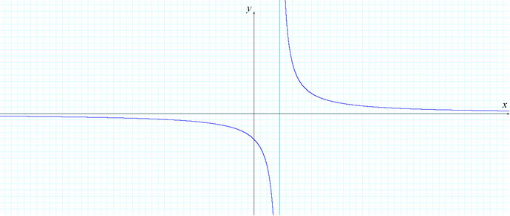

https://content.umuc.edu/file/7bdece95-b196-4233-9313-aa904663b08e/1/MATH140-0909.zip/Modules/M2-Module_2/Lesson_2/images/MATH14-mod2-lessn2-Table-2-2-10a-figtitle.gif

|  |  |
| --- | --- |
| ***x*** | ***f*(*x*) = 1/(*x* – 1)** |
| 10 | 0.11111111 |
| 100 | 0.01010101 |
| 1000 | 0.00100100 |
| 10000 | 0.00010001 |
| 100000 | 0.00001000 |
| 1000000 | 0.00000100 |

https://content.umuc.edu/file/7bdece95-b196-4233-9313-aa904663b08e/1/MATH140-0909.zip/Modules/M2-Module_2/Lesson_2/images/MATH14-mod2-lessn2-Table-2-2-10b-figtitle.gif

|  |  |
| --- | --- |
| ***x*** | ***f*(*x*) = 1/(*x* – 1)** |
| –10 | –0.09090909 |
| –100 | –0.00990099 |
| –1000 | –0.00099900 |
| –10000 | –0.00009999 |
| –100000 | –0.00000999 |
| –1000000 | –0.00000099 |

The graph of *f* and the tables of values show that, as *x* grows arbitrarily large positive, the values of *f* approach 0, and as *x* grows arbitrarily large negative, the values of *f* again approach 0. We see this in figure 2.2.14a, observing the far-right behavior of the graph of *f* (tending toward 0) and the far-left behavior of *f*(also tending toward 0). We write this symbolically as

https://content.umuc.edu/file/7bdece95-b196-4233-9313-aa904663b08e/1/MATH140-0909.zip/Modules/M2-Module_2/Lesson_2/images/MATH14-mod2-lessn2-ex2-2-8-prob.gif= 0 OR https://content.umuc.edu/file/7bdece95-b196-4233-9313-aa904663b08e/1/MATH140-0909.zip/Modules/M2-Module_2/Lesson_2/images/MATH14-mod2-lessn2-ex2-2-8-prob1.gif = 0

Definition 7

* 1. If the function *f* is defined on an open interval (*c*, ∞), then

https://content.umuc.edu/file/7bdece95-b196-4233-9313-aa904663b08e/1/MATH140-0909.zip/Modules/M2-Module_2/Lesson_2/images/limit-x-to-infinity.gif *f*(*x*) = *A*

(Read as, "The limit of *f*(*x*) as *x* approaches infinity is *A*.") This means that the values of *f*(*x*) become arbitrarily close to the number *A* when we consider *x* sufficiently large in a positive direction.

* 1. Let *f* be a function defined on an open interval (–∞, *c*). In this case,

https://content.umuc.edu/file/7bdece95-b196-4233-9313-aa904663b08e/1/MATH140-0909.zip/Modules/M2-Module_2/Lesson_2/images/limit-x-to-minus-infinity.gif *f*(*x*) = *A*

(Read as, "The limit of *f*(*x*) as *x* approaches negative infinity is *A*.") This means that the values of *f*(*x*) become arbitrarily close to the number *A* when we consider *x* sufficiently large in a positive direction.

**Example 2.2.2: Far-Right Behavior of *f*(*x*)**

We can visualize the situations described in Definition 7 involving the far-right behavior of *f*(*x*) as *x* → ∞. The figures illustrate only some of the ways in which a graph can approach a limit *L* (graphically, the line *y* = *L*) as *x* → ∞.

**https://content.umuc.edu/file/7bdece95-b196-4233-9313-aa904663b08e/1/MATH140-0909.zip/Modules/M2-Module_2/Lesson_2/images/MATH14-mod2-lessn2-ex2-2-14a-figtitle.gif**

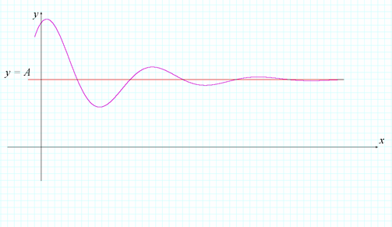

**https://content.umuc.edu/file/7bdece95-b196-4233-9313-aa904663b08e/1/MATH140-0909.zip/Modules/M2-Module_2/Lesson_2/images/MATH14-mod2-lessn2-ex2-2-14b-figtitle.gif**

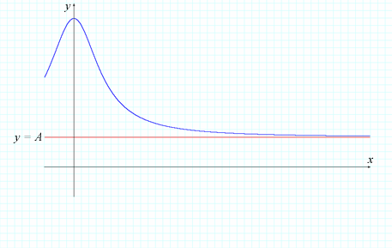

**https://content.umuc.edu/file/7bdece95-b196-4233-9313-aa904663b08e/1/MATH140-0909.zip/Modules/M2-Module_2/Lesson_2/images/MATH14-mod2-lessn2-ex2-2-14c-figtitle.gif**

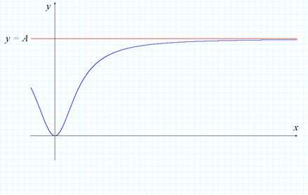

Definition 8

A line *y* = *A* is called a **horizontal asymptote** of the graph of a function *y* = *f*(*x*) if any of the following conditions hold:

https://content.umuc.edu/file/7bdece95-b196-4233-9313-aa904663b08e/1/MATH140-0909.zip/Modules/M2-Module_2/Lesson_2/images/limit-x-to-infinity.gif *f*(*x*) = *A* OR https://content.umuc.edu/file/7bdece95-b196-4233-9313-aa904663b08e/1/MATH140-0909.zip/Modules/M2-Module_2/Lesson_2/images/limit-x-to-minus-infinity.gif *f*(*x*) = *A*

In the focus feature below, apply what you have learned to the case referenced in the overview of this module.

Focus on Calculus:   
In the Life Sciences



Source: University of Texas Libraries, 2009, The University of Texas at Austin Web site. Used with permission.

You are a public health official. You read that, according to the Pan American Health Organization (PAHO) and the World Health Organization (WHO), any "sudden and marked change" in the influenza A virus should be considered one of "the greatest public health concerns" in the Americas (PAHO, 2003, PAHO Web site).

According to the PAHO, vaccination plays an important role in the management of a suddenly altered virus. You are evaluating two vaccines under consideration for a dangerous A virus. The concentrations *C*1 and *C*2 from a single flu shot of each vaccine in milligrams (mg) per liter after *t*hours in the bloodstream is modeled by the following equations:

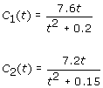

Complete the following and feel free to ask your instructor or fellow students any questions you have.

* 1. Find the horizontal asymptote of the functions *C*1(*t*) and *C*2(*t*). Interpret what the horizontal asymptote represents for each with respect to the concentration of flu medication in the bloodstream with the passage of time.
  2. Graph the functions *C*1 and *C*2 (*t* > 0) and use the graphs to determine which vaccine will stay in the bloodstream the longest. Which vaccine do you consider more useful, assuming that both effectively treat the A virus? Explain your reasoning.

**References**

Pan American Health Organization (PAHO). (2003). Planning for a flu pandemic. Retrieved April 28, 2009, from http://www.amro.who.int/English/DD/PIN/ptoday17_oct03.htm

University of Texas Libraries, The University of Texas at Austin. (1772). The world (map). Retrieved May 11, 2009, from http://www.lib.utexas.edu/maps/historical/colbeck/world_1772.jpg. Used with permission.

[*Return to top of page*](https://content.umuc.edu/file/7bdece95-b196-4233-9313-aa904663b08e/1/MATH140-0909.zip/Modules/M2-Module_2/Lesson_2/S3-Commentary.html#pagetop)

[**Report broken links or any other problems on this page.**](http://help.umuc.edu/)  
  
[**Copyright © by University of Maryland University College.**](https://content.umuc.edu/file/7bdece95-b196-4233-9313-aa904663b08e/1/MATH140-0909.zip/common/copyright.html)